Lớp 5 - Unit 13 What do you do in your free time?|WRITING |

|  |  |
| --- | --- |
| **Full name: ………………………………………..**  **Class: ………………………………………………** | **ENGLISH LANGUAGE TEST**  **Time: 15 minutes** |

I. WRITING

Task 1. Look at the pictures. Read and write one word for each gap. There is one example.

*Example:*

 I like swimming.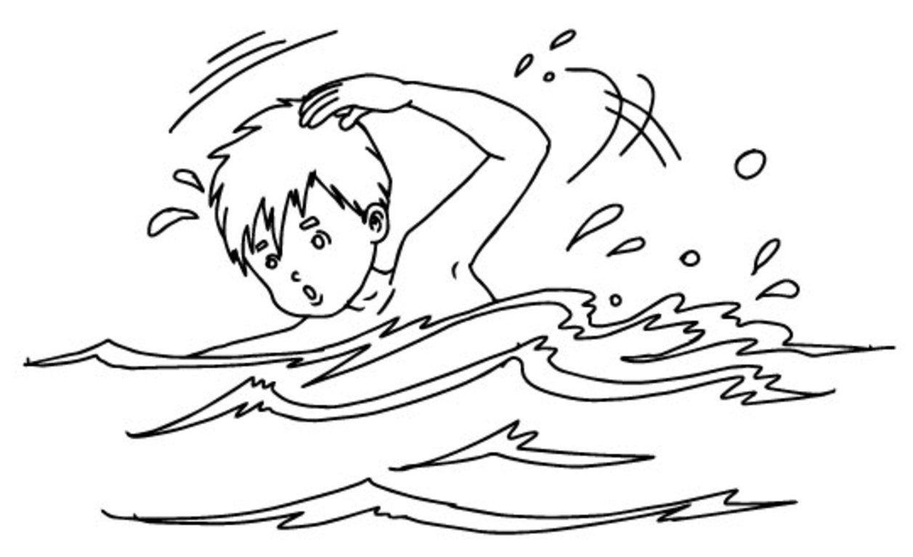

1. We often go __________ in summer.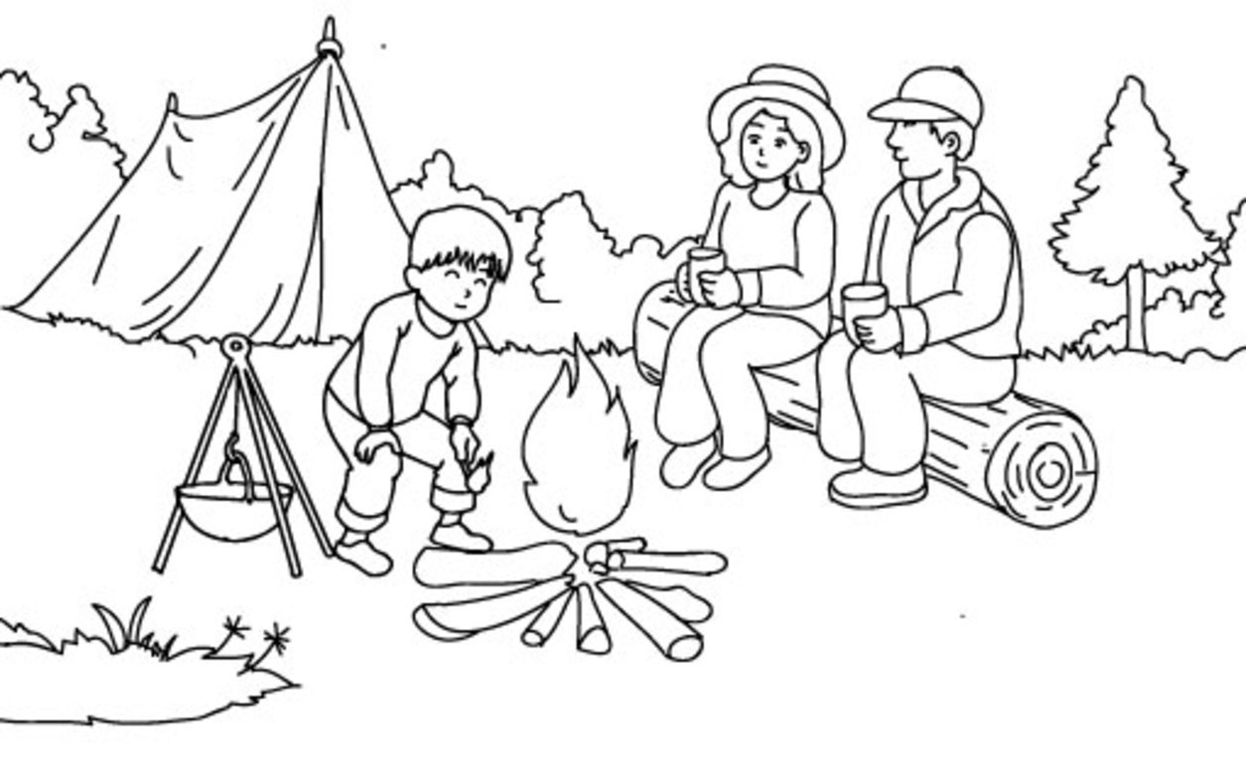  
  
2. Mr Smith often surfs the ______________ in the evening.  
  
3. My brother goes ___________ every Sunday.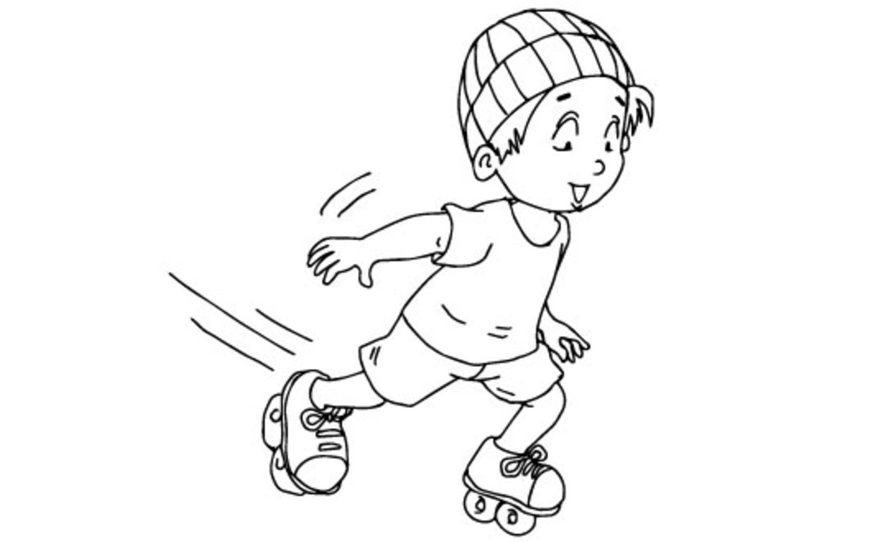  
  
4. I often do ____________ in the gym.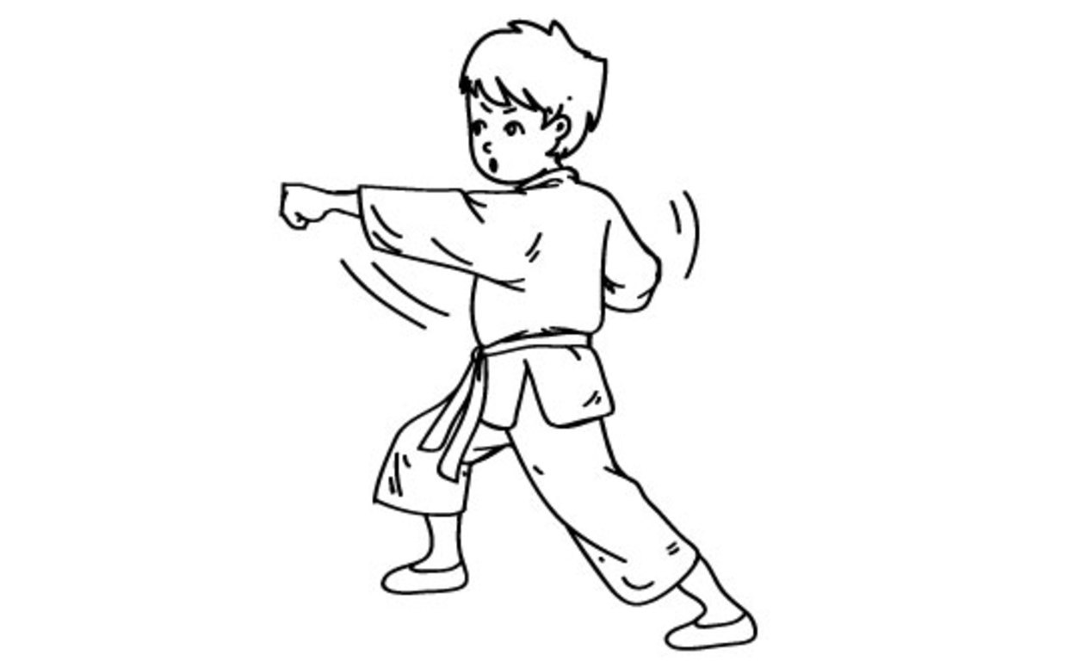  
  
5. I ride my _____________ in the park every Sunday.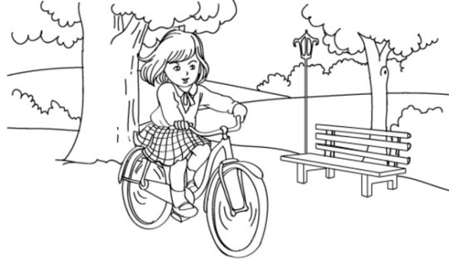

Task 2. Order the words. There is one example.

*Example:* watch / in / I / my / time / free / TV  
                   I watch TV in my free time.

1. often / what / in / free / do / you / time / do / your  
_____________________________________________?  
2. a / my / twice / swimming / week / goes / sister  
_____________________________________________.  
3. do / in / karate / my / I / time / free / often  
_____________________________________________.  
4. often / go / you / how / English / the / club / to / do  
_____________________________________________?  
5. one / fishing / brother’s / of / my / is / hobbies  
_____________________________________________.

Task 3. Read the questions. Write about yourself. There is one example (0).

|  |
| --- |
| 0. What’s your name? 1. What do you do in your free time? 2. Why do you do that in your free time? 3. How often do you do that? 4. Who do you like to spend your free time with? 5. What do your parents often do in their free time? |

|  |
| --- |
| Hello. (0) My name is                           . 1. I often ________________________. 2. I _________________________ because_______________________. 3. I _______________________________________________________. 4. I _______________________________________________________. 5. My parents _______________________________________________. |

– The end –

manual page break

# Đáp án

I. WRITING

Task 1. Look at the pictures. Read and write one word for each gap. There is one example.

**Key:** 1. camping 2. Internet 3. skating 4. karate 5. bike

Task 2. Order the words. There is one example.

**Key:**  
1. What do you often do in your free time?

2. My sister goes swimming twice a week.

3. I often do karate in my free time.

4. How often do you go to the English club?

5. Fishing is one of my brother’s hobbies. (/ One of my brother’s hobbies is fishing.)

Task 3. Read the questions. Write about yourself. There is one example (0).

Student’s answers vary with correct grammar.